# **LTE Initial Access (All about Cell Search, Cell Selection, PSS, SSS)**

A UE must perform certain steps before it can receive or transmit data. These steps are-

–****cell search****

****– cell selection****

****– Derivation of system information and****

****– Random access.****

The complete procedure is known as ****LTE Initial Access****.

Although there can be many algorithms defined for this procedure the basic sequence is as follows:-

1. UE tune to every channel it supports and measure RSSI.

2. From the list of 1. all channels with RSSI > a threshold value is determined..

3. UE decode sync/reference signals and find Physical Cell Id of each candidate from 2.

4. Of all the cells of step 3. UE decode MIB and SIB. Now, UE has a list if frequency, PCI and PLMN of the filtered cells.

5. From all of the above information, UE makes a descision of on which of these cells it would camp on.

Now, lets get into details.

1.  ****UE tune to every channel it supports and measure RSSI****:-

In the equipment, operator stores all the frequency bands it supports. Based on that information UE will scan all those channels and measure the RSSI. RSSI is Received Signal Strength Indicator. It is total signal power of each resource element including interference or noise. This is included here in measurement since UE currently does not have any information about network and measuring this parameter doesn’t require any channel coding process.

2. ****From the list of 1. all channels with RSSI > a threshold value is determined.****

This is implementation dependent

3. ****UE decode sync/reference signals and find Physical Cell Id of each candidate from 2:-****

There are 504 Physical Cell Identities(PCI). These identities are divided into 168 unique cell layer identity groups in the physical layer, in which each group consists of 3 physical layer identities.  
This information is transmitted using two different signals. The two signals, carrying the physical layer identity and the physical layer cell identity group, are the primary and the secondary synchronization signals respectively

The UE first looks for the ****primary synchronization signal (PSS)**** which is transmitted in the last OFDM symbol of the first time slot of the first subframe. This enables the UE to acquire the slot boundary independently from the chosen cyclic prefix used in this cell. PSS is transmitted twice per radio frame, so it is repeated in subframe 5 (in time slot 11). This enables the UE to get time synchronized on a 5 ms basis, This was done because if a UE starts reading cell from between a subframe, it can get time synchronized.

In FDD, PSS is broadcast using the central 62 subcarriers.

The PSS is used to:  
– Achieve time syncronization.  
– Identify the center of the channel bandwidth in the frequency domain  
– Finds which 1 of 3 Physical layer Cell Identities (PCI), cell belongs  
PCI are organised into 168 groups of 3 so the Primary Synchronisation Signal identifies the position of the PCI within the group but does not identify the group itself.

****Secondary Syncronization symbol**** (SSS) is located in the symbol before PSS, transmitted twice per subframe. The two transmissions of the SSS are different so the UE can detect which is the first and which is the second. This sequence alternates in even and odd subframes, ex In subframe1 sequence A is transmitted in symbol a and sequence A’ is transmitted in symbol b, then in subframe 2 sequence A is transmitted in symbol b and sequence A’ is transmitted in symbol a. This way subframe syncronization is achieved.

SSS is also transmitted in central 62 subcarriers in the symbol before PSS.

The SSS is used to:  
– achieve radio frame synchronisation  
– Find which 1 of 168 Physical layer Cell Identity (PCI) groups is used,  
Hence,the PCI could be deduced when combined with the pointer from the PSS. Following formula is used:-

PCI  = 3*physical layer id group(from SSS)+phy layer cell id(from PSS).

4. ****Of all the cells of step 3. UE decode MIB and SIB. Now, UE has a list if frequency, PCI and PLMN of the filtered cells:-****

Here, I am not explaining the structure of MIB and SIB. At this point UE knows the PLMN from SIB1 and can select the cell to camp on.

UE finds a suitable cell. A suitable cell is one that fulfills cell selection criteria.

Criteria for Cell Selection are:-

– Cell must transmit power strong enough to be detected by UE.

i.e  Srxlev > 0  
Where,  
Srxlev = Qrxlevmeas – (Qrxlevmin+Qrxlevminoffset) – Pcompensation

Qrxlevmeas     = RSRP measured by UE in dBm  
Qrxlevmin       = min. required RSRP signalled within SIB1  
Qrxlevminoffset  = usually included in SIB1. If not included than value of zero is set.  
Pcompensation = MAX(PEMAX – PUMAX, 0)

These values are decoded from SIB.

– Cell must not be barred.

– PLMN saved in UE sim must match with cell’s PLMN.

There are 2 types of cell selection:-

– Initial cell selection,

– Stored procedure cell selection.

In the initial cell selection procedure, as described above, no knowledge about RF channels is available at the UE. In that case the UE scans the supported E-UTRA frequency bands to find a suitable cell. Only the cell with the strongest signal per carrier will be selected by the UE.

The second procedure uses information about carrier frequencies and optionally cell parameters received and  
stored from previously-detected cells. If no suitable cell is found using the stored information the UE starts with the initial cell selection procedure.

LTE UE Initial Access

[Prasanna Sahu](http://www.3glteinfo.com/author/prasanna/" \o "Posts by Prasanna Sahu) March 3, 2011 [2](http://www.3glteinfo.com/lte-ue-initial-access/" \l "comments)

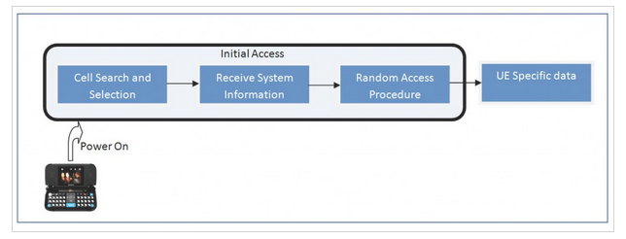

UE Initial Access is the process between an UE is switched on and before sending UE specific signaling or data. The different steps for initial access are described below.

Cell Search and Selection

Receive System information

Random access procedure

Cell Search and Selection

In order to know the cell search and selection first we have to know the physical signals and Physical channels in downlink for cell search and selection.

Signals in downlink

Primary and secondary Synchronization signal

Cell Specific Down Link reference signal

LTE Downlink Physical Channels

Physical Broadcast Channel(PBCH): Provides essential system information(System Bandwidth)

LTE follows a hierarchical cell search, which means from primary and secondary synchronization signal it extracts the cell id and cell group id respectively. Then it combines both in a hierarchical manor to generate physical cell identity. For details about Physical hierarchy please follow the Note below  
Note: Physical Cell id can be any no starting from 0-503. In order to manage this huge amount of cells, LTE has divided them in to 168 groups and in each group there can be 3 cells.  
So Physical Cell ID = Cell Group ID * 3 + Cell ID

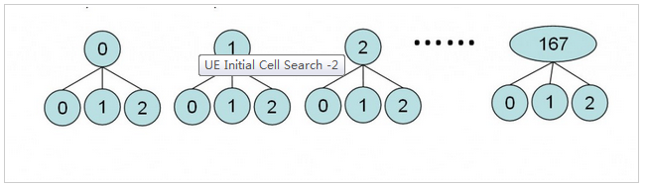

It may happen that UE is at the interference area of multiple cells; in that case UE may get multiple cell ids. In order to camp on a particular cell it has to decode cell specific reference signals.

Cell specific reference signal contains

Downlink channel estimation for coherent demodulation.

Channel Quality Indicator (CQI= QPSK/16 QAM/64 QAM depending on the signal strength).

Based on these parameters UE camps on a particular cell, and proceed to the next step “Receiving system information”

System Information Reception

[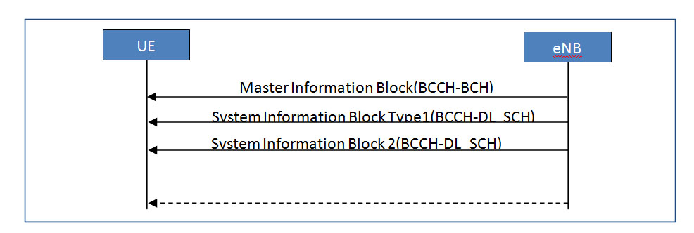](http://www.3glteinfo.com/wp-content/uploads/2011/03/UE-Initial-Cell-Search-3.jpg)

After the cell selection now UE configures the BCCH-BCH channel and maps it on PBCH to receive Master Information Block (MIB).

Master Information Block (MIB)

Dl bandwidth

PHICH related information

After receiving MIB UE reconfigure the BCCH-DL-SCH channel and map it on PDSCH to receive System Information Block Type1 (SIB1).

System Information Block Type1 (SIB1)

PLMN Information

TAC

Physical Cell ID and specific info

Scheduling information of other System Information Blocks(SIB2, SIB3, SIB4….)

After receiving the SIB1 UE gets the scheduling information about other SIBs (In which sub-frame, the subsequent SIBs can be received). But the most important SIB block for basic call in LTE is SIB2. So UE reconfigures the BCCH-DL-SCH to receive the SIB2.

System Information Block 2(SIB2)

Common Channel Information

Random Access Channel Information

Random Access Preamble Info

HARQ info

Till now all the things that are happening is on down link. After Sib2 reception UE configures the Random Access Channel and Common shared channel and starts uplink synchronization using Random Access Procedure.

Random Access Procedure:

In LTE all the UE uses the same shared resources to get the initial access. So Random Access Procedure is always contention based. In this procedure UE get the initial UL grant to transmit UE specific UL packets for first time.

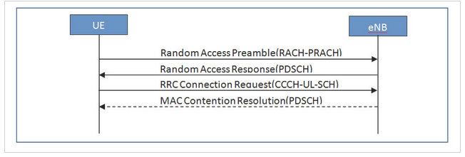

Random Access Preamble:

This is generated by MAC layer in uplink on RACH-PRACH. There are two possible groups defined group A and B from which one is optional. If both groups are configured, the size of message 3 and the path loss are used to determine preamble group. The group to which a preamble belongs provides an indication of the size of the message 3(RRC Connection req) and the radio conditions at the UE. The preamble group information and thresholds are already been received in system information block 2.

Random Access Response:

This is generated by MAC in downlink on DL-SCH-PDSCH. After sending the Random Access Preamble UE watches the RA-RNTI in PDCCH. From that it gets the information about the Random Access Response (in which sub frame it is arriving in PDSCH). This response carries the temporary C-RNTI assigned by the eNB and UL grant. C-RNTI is used for transmission and reception of UE specific UL and DL data.  
Note: UL and DL transmission and scheduling can be discussed in some other post.

RRC Connection Request :

This is generated by RRC layer on CCCH-UL_SCH. This is called as message3 and first UE specific signalling from L3(RRC). This carries the UE specific identity. The UE identity can me Random or S-TMSI (if UE is already registered to the EPC and S-TMSI is with UE). It also carries the establishment cause.

MAC Contention Resolution:

This is generated by MAC on DL-SCH. It may happen that simultaneously more than one RRC connection request is received at eNB on same shared channel. So in order to separate out the UEs eNB uses the contention resolution much prior to the NAS based contention. Here LTE uses the timer based contention resolution. After receiving the message3 eNB schedules that request and send the information to the UE through MAC contention resolution message.

LTE References

For LTE check out [LTE for UMTS: Evolution to LTE-Advanced](http://www.amazon.com/gp/product/0470660007/ref=as_li_tf_tl?ie=UTF8&tag=3glteinfo-20&linkCode=as2&camp=217145&creative=399381&creativeASIN=0470660007)IMG_260 and [LTE Signaling: Troubleshooting and Optimization](http://www.amazon.com/gp/product/0470689005/ref=as_li_tf_tl?ie=UTF8&tag=3glteinfo-20&linkCode=as2&camp=217145&creative=399381&creativeASIN=0470689005)IMG_261